Bits of Buchan

Elery Hamilton-Smith, AM

An exhibition at the Visitor Centre, Buchan Caves

16th March – 4th May 2007

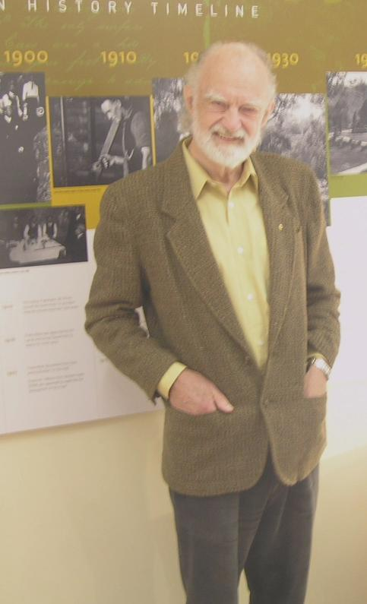

This presentation is based upon an exhibition that was mounted as one event in the course of celebrating Frank Moon’s discovery of Fairy Cave on 16th March 1907.

It includes a variety of memorabilia from the collection of Elery
Hamilton-Smith, but was developed in partnership with Parks Victoria,
with Catherine Bessant of that organization being responsible for
the production and presentation of the actual exhibits. We also acknowledge the support of Rauleigh Webb in providing some of the photographs used in this presentation and all staff at Buchan for their assistance with the exhibition.

Buchan Caves were probably discovered very soon after white settlers arrived in 1838, but attracted little notice until the later part of the 19th Century.

